
Westover Police Department
500 Dupont Road
Westover, WV 26501
(304)296-6576, Fax (304)225-3907

Dear Applicant:

The Westover Police Civil Service Commission will administer the Police Officer entry-level testing on Saturday, February 07, 2026, at 9:00 am, at Westwood Middle School, 670 River Road, Westover, WV 26501. An information sheet outlining requirements for employment with Westover Police Department is attached.

Arrive on testing day dressed in attire appropriate for oral interviews before the Civil Service Commissioners. All applicants who pass the written test will be interviewed by the commissioners and then will have time to change into appropriate attire to take the physical agility test. The written test, oral interviews, and the physical agility test will take place the same day at Westwood Middle School, 670 River Road, Westover, WV 26501. Any applicant who fails all or any portion of the physical agility test will be given an opportunity to retake that test within 30 days of the test date. Veterans may qualify for 5 or 10 additional points to be added to their passing score, to qualify for the additional points you must meet the requirements in West Virginia State Code 6-13-1 (Veterans may inquire about the requirement for the extra points on the day of the test or prior to the test date at this email - scarl@westoverwv.gov.

BRING WITH YOU TO THE TEST:
- Your valid driver’s license or a government-issues I.D.
- Two soft lead #2 pencils.
- Clothes to take the PT Test (ie. running shoes, shorts or sweat pants).

Failure to attend the written exam will disqualify applicants from the current hiring process. There are no make-up or alternate dates for the test at a later date. The written exam is numerically scored, and the agility test is pass/fail. The written examination will be the National Police Officer Selection Test (POST), https://www.stanard.com/public-safety/police-test/the-national-police-officer-selection-test . A study guide and practice test for the POST can be found at https://www.applytoserve.com/Study/ .

In an effort to ensure all needs are met, requests for special accommodations should be made to the Deputy Chief at the above listed telephone number or via email at scarl@westoverwv.gov, prior to the test date. Should you have any questions regarding the testing procedures please contact Deputy Chief S. E. Carl.

The application deadline is Friday, February 06, 2026, at 5 pm. Applications must be received by this date and time.

Thank you,

The City of Westover
Police Civil Service Commission and
The Westover Police Department

Westover Police Department
500 Dupont Road
Westover, WV 26501
(304)296-6576, Fax (304)225-3907

Requirements and Benefits

The Westover Police Civil Service Commission is accepting applications for entry-level Police Officer. The entry-level civil service exam which will be held on Saturday, February 07, 2026, at 9:00 am, at Westwood Middle School, 670 River Road, Westover, WV 26501. Applications are available online at www.westoverwv.org and click on the “police” tab and go to “join our team” or in person at Westover City building located at 500 Dupont Road, Westover, WV 26501. Completed applications must be submitted to the Deputy Chief’s office no later than February 07, 2026 by 5:00 pm.

Requirements include the following:
- Must be 18 years of age at time of application. 8-14-12(c) There shall be no other age-based restrictions on applications for original appointments
- Must be a citizen of the United States.
- Possess a High School Diploma or GED.
- Must establish, and maintain a permanent physical residence within 35 air miles-as shown on map- of the main station of the Westover Police Department, 500 Dupont Road, Westover, WV 26501, and shall continue to maintain his/her permanent physical residence within the residency area for the entire period of his/her active employment with the Westover Police Department. This residency requirement must be achieved within 90 days of notification of permanent status.
- Must successfully complete and pass all the following examinations:
-Physical Agility Test
-Written Police Skills Test
-Background Investigation
-Polygraph Examination
-Drug Test
-Medical Examination
-Vision Test
-Psychological Examination
-Personal Interview
FORMS ON PAGES 8-10 OF THE APPLICATION MUST BE SIGNED AND TURNED IN WITH APPLICATION

Base Salary Non-Certified = $47,112.00 ($22.65).
Certified Officer = $51,168.00 ($24.60) If certified prior to hiring, $1000.00 bonus after completion of the FTO Program.
After 1-year probationary period, base salary = $54,288.00 ($26.10). This includes 1 year longevity pay.

State Wide MPRFS Pension Plan, Uniform & Equipment Provided, Health/Life Insurance provided by High Mark Blue Cross and Blue Shield with $5000.00 deductible for single and a $10,000.00 deductible for family paid for by the City of Westover, Eye and Dental Insurance, Sick Leave and Vacation Leave.

Education Benefit – and employee may be reimbursed for job-related tuition, books and student fees.

Longevity pay compounded as follows: after one year $.25 cents per hour, after 5 years $.50 cent per hour, after 10 years
$.75 cents per hour, after 15 years $1.00 dollar per hour, $1.00 dollar per hour
added every 5 years after 15 years.

The City of Westover provides equal employment opportunities to all employees and applicants for employment without regard to race, color, religion, national origin, sex, sexual orientation, gender identity, disability, genetic information, or age.

- Must establish, and maintain a permanent physical residence within 35 air miles-as shown on map- of the main station of the Westover Police Department, 500 Dupont Road, Westover, WV 26501, and shall continue to maintain his/her permanent physical residence within the residency area for the entire period of his/her active employment with the Westover Police Department. This residency requirement must be achieved within 90 days of notification of permanent status.

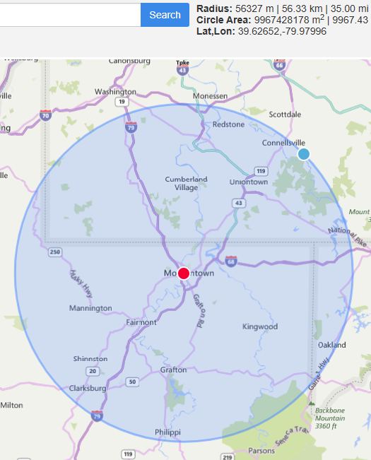

PRE-EMPLOYMENT PHYSICAL AGILITY SCREENING

FOR West Virginia STATE AND LOCAL LAW ENFORCEMENT OFFICERS
PRE-EMPLOYMENT PHYSICAL AGILITY SCREENING

The ADA provides that “an employer may give a physical agility test to determine physical qualifications necessary for certain jobs prior to making a job offer if it is simply an agility test and not a medical examination.” Moreover, if an employer uses such a test, he must be prepared to demonstrate the job-relatedness of the test and that the test is consistent with business necessity.
The ADA Technical Assistance Manual, furthermore, clarifies that an agility test does not involve medical examinations or diagnoses by a physician. However, an employer “can request the applicant’s physician to respond to a very restricted inquiry which describes the specific agility test and asks: “Can this person safely perform this test?”.
In light of the above and the necessity in policing that physical capacity to learn and perform essential tasks must be demonstrated, the Commission devised a Pre-Employment Physical Agility Waiver of Liability that is attached to the application.
Based on the significant work of the Cooper Institute for Aerobics Research, the Commission proposed the battery of screening elements which are contained on the following page. The Commission recommends this process because its elements get to a candidate’s ability and does not have adverse impact. Also, it is the Commission’s expectation that these elements can and will be administered locally and a determination of pass/fail made there as well. Failure in any one element is sufficient to exclude the person from proceeding any further in the selection process. The instruction titled “How to Prepare for the Tests” also follows below and should be distributed to applicants well before test administration. Nevertheless, if a person fails an element, retesting can be provided if it suits the employer.
*See Americans with Disabilities Act – A Technical Assistance Manual, U.S. EEOC, 1992, pp. IV- 8/IV-9

PRE-EMPLOYMENT PHYSICAL AGILITY SCREENING

FOR West Virginia STATE AND LOCAL LAW ENFORCEMENT OFFICERS
TEST WILL BE GIVEN THE SAME DAY AS THE WRITTEN TEST

West Virginia Legislative Rules §149-2-8.5 Physical Ability Standards, which determine an applicant officer’s, pass/fail screening for admission into the basic entry level training program.

Agility Requirements
- Sit-ups: Twenty-Eight (28) bent-leg sit-ups completed in one (1) minute.
- Push-ups: Eighteen (18) conventional push-ups completed in one (1) minute.
- One and one-half mile run – Fourteen Minutes and thirty-six seconds (14:36) as the elapsed time to complete run.

The test battery which has been described herein should be performed locally only as a pass/fail screening device. Once a candidate passes the elements according to the scores stated on the Pre-Employment Physical Agility Test Battery, the remaining elements of the local selection process may be applied.

RELEVANCE OF TEST ITEMS TO ESSENTIAL TASKS

The three elements of the test battery are designed to establish physical capacity to produce recruit level training and perform the essential tasks of policing. They are not simulations but rather assessments of the candidate’s capacity to learn and perform essential physical tasks.

HOW TO PREPARE FOR THE TESTS

The following guidelines are presented based on a twelve (12) week period preceding screening.

Preparing for the MUSCULAR ENDURANCE test:

The progressive routine is to do as many bent-leg sit-ups (hands behind the head with someone holding your feet) as possible in one minute. At least three (3) times per week do three (3) sets (three (3) groups) of the number of repetitions you did in one (1) minute.

Preparing for the ABSOLUTE STRENGTH test:

If you have access to weights, determine the maximum weight that you can bench press one time. Take 60% of that poundage. This will be your training weight. You should be able to do 8-10 repetitions of that training weight. Do three (3) sets of 8-10 repetitions adding 2 ½ to 5 pounds every week.

If you do not have access to weights, then the push-up exercise can be used. Determine how many push- ups you can do in one minute. At least three (3) times per week do three (3) sets of the amount you can do in one minute.

Preparing for the CARDIOVASCULAR CAPACITY test:
Below is a gradual schedule that would enable you to perfom1 a maximum effort for the 1.5-mile run. If you can advance the schedule on a weekly basis, then proceed to the next level. If you can do the distance in less time, then that is encouraged.

WEEK | ACTIVITY | DISTANCE | TIME | FREQUENCY
 |  | (Miles) | (Minutes) | (Per Week)
1 | Walk | 1 | 17-20 | 5
2 | Walk | 1.5 | 25-29 | 5
3 | Walk | 2 | 32-35 | 5
4 | Walk | 2 | 28-30 | 5
5 | Walk/Jog | 2 | 27 | 5
6 | Walk/Jog | 2 | 26 | 5
7 | Walk/Jog | 2 | 25 | 5
8 | Walk/Jog | 2 | 24 | 4
9 | Jog | 2 | 23 | 4
10 | Jog | 2 | 22 | 4
11 | Jog | 2 | 21 | 4
12 | Jog | 2 | 20 | 4

